Cranston Public Schools

Snow/Inclement Weather/Emergency Information
November 2018
Please review the following information and be aware of how/when we delay or cancel school for your children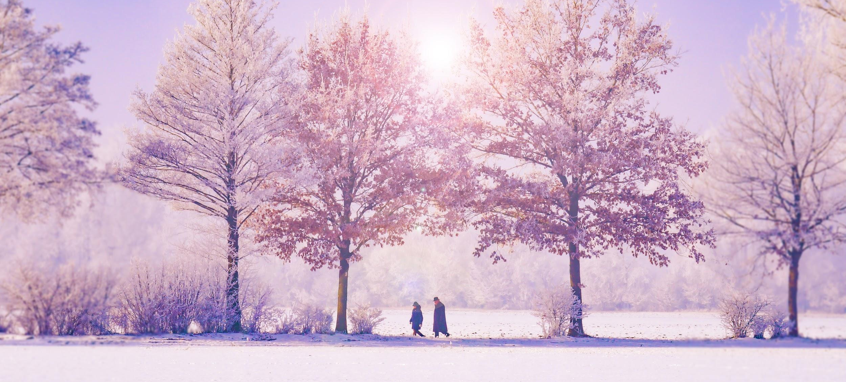. School delays or cancellations may be announced in the following ways:
- RI Broadcasters Association. If you have not signed up for instant text alerts from RIBA, right click on this link to open http://goo.gl/cCNX4h. Sign up for alerts from Cranston Public Schools. **This is the quickest method of notification. We strongly encourage all staff and families to register for these alerts.**
- CPS website: http://cpsed.net/
- CPS Facebook page: CPS FB
- District and/or school emails
- Robocalls to homes will be used for emergency purposes only, or when used by law enforcement
Delayed Openings
The RI Department of Education has recently allowed districts more flexibility with delayed openings. When appropriate, we will delay the start of school. Delays can be anywhere from 1-2 hours. Know the normal start time of your child’s school, so if a delay is announced you will know when the children are expected to be in school. Buses will be delayed for the same amount of time as school openings (i.e. 1 or 2 hours), but expect slight variations in bus times due to weather.

Cancellations
In very harsh or dangerous weather, we will cancel schools for the entire day. Additionally, if after-school sports or activities are cancelled due to inclement weather, these announcements will be made as soon as possible on CPS website, CPS Facebook page, RIBA, emails and/or schools’ listservs.
Early Dismissal
Unless absolutely necessary, we will not release schools early. This is the most disruptive option for families and our schools. However, we need to plan for emergencies that may arise when this is deemed necessary.
We will use all media previously mentioned to contact families in the event we release schools early. Individual schools will also use their listservs to reach families in these cases.
If we close schools early, buses will deliver their students to their appointed stops. Again, please be patient as we deliver all students with safety in mind. If your children walk, or you pick up your children at school, please discuss an alternate plan with your children so they are aware of what will happen if school is released early.
Student and staff safety is paramount in the decisions made to cancel or delay school. It is important that families have a plan ready for times when these delays or cancellations occur.
All delay/cancellation decisions are made in collaboration with CPS Transportation, Buildings and Grounds Departments, as well as City of Cranston Police and Public Works Departments. Often Rhode Island Emergency Management (RIEMA) and Cranston Emergency Management are consulted in cases when power outages or violent weather is expected.

